ADMINISTRATION GUIDE

LAMBTON KENT SOCCER ASSOCIATION

 PAGE

1.**REGISTRATION POLICIES**

Team Classifications 2

Player Registration Book/Validation Page 4

Classification by League & Youth Levels 6

Form A – Volunteer Screening Form 7

2. **TEAM REGISTRATION PROCEDURES** 8

District Requirements for Validation of U13 & Older Roster and Books 8

Team Applications to Leagues 8

Team Playing Out Applications Approval Process 8

All Star Team Registrations (U13 – U18 only) 8

Form B – All-Star Roster 9

3. **REGISTRATION & DISTRICT VALIDATION OF PLAYER POOLS** 10

Registration using the OSA Registration System 10

Validation of Player Pools (U8 – U12) 10

4. **OTHER REGISTRATION RELATED PROCEDURES** 11

Team Official Registration 11

Administrator/Director Registration 11

Club Head Coach and Technical Staff 11

De-Registration of a Player 12

**PAGE**

**1. REGISTRATION POLICIES** 1

Team Classifications 2

Player Registration Book/Validation Page 4

Classification by League & Youth Levels 6

Form A – Volunteer Screening Form 7

2. **TEAM REGISTRATION PROCEDURES**  8

District Requirements for Validation of U13 & Older Roster and Books 8

Team Applications to Leagues 8

Team Playing Out Applications Approval Process 8

All Star Team Registrations (U13 – U18 only) 8

Form B – All-Star Roster 9

3. **REGISTRATION & DISTRICT VALIDATION OF PLAYER POOLS** 10

Registration using the OSA Registration System 10

Validation of Player Pools (U8 – U12) 10

4. **OTHER REGISTRATION RELATED PROCEDURES** 11

Team Official Registration 11

Administrator/Director Registration 11

Club Head Coach and Technical Staff 11

De-Registration of a Player 12

Player Transfer Between Clubs/Academies 12

Form C – Player Transfer/De-Registration Form 13

Registered to Play Up Within the Same Club 14

Player Being Used as Guest Player Within the Same Club 14

Playing from Club to Club – Temporary Eligibility Permit 14

Permit for Unregistered Players – Short Term Registration Permit 15

Playing in a US Tournament/Exhibition Game for a Team

For which a Player is NOT registered to 15

Individual Players Playing for a US Team in an Exhibition Game

or Tournament 15

Form D – Ontario Soccer Playing Up Forms 16

Form E –Grassroots Emergency Play Up Form 17

Form F – Temporary Eligibility Permit (TEP) 18

Form G – Short Term Registration Permit (STRP) 19

5. **CERTIFICATE OF INSURANCE/3rd PARTY INSURANCE** 20

Form H – Certificate of Insurance Form (Sample) 21

6. **INTERNATIONAL PLAYER TRANSFERS** 22

7. **TRAVEL PERMITS** 23

Travel Permits (ATF) 23

Approval and Travel to Exhibition Games (U9 and Older) 24

**1 REGISTRATION POLICIES**

**1.1** Every person involved in any soccer activity must be registered in the Ontario Soccer

computerized registration system. This includes all Board Members, Administrators, Team Officials and

Players. This applies to both indoor and outdoor seasons.

**1.2** The Club/Academy Administrator or designate will be the primary contact with the LKSA for the

purposes of registering all Administrators, Team Officials and Players for the Club/Academy.

**1.3** The Club/Academy Administrator must ensure that Player and Team Official registration

forms/waivers are completed in their entirety and signed prior to entering the individual in the Ontario

Soccer Registration System.

**1.4** A Club/Academy failing to register all of its participants is subject to discipline.

**1.5** A Club/Academy must enter their own registration data into the Ontario Soccer Registration

System

**1.6** A Club/Academy that wishes to design and use its own Registration forms must have these forms

approved by LKSA prior to the beginning of the season. Standard Player registration forms can be

found on the ONTARIO SOCCER website.

At no time will health card numbers or S.I.N. be required.

At the time of registration an Ontario Soccer Registrant number is assigned to those who do not have

one.

**1.7** Players U13 - U18, can be registered in their age category or higher where approved by the

Club/Academy. With the permission of LKSA, a U13 – U18 Player may register on a maximum of three

outdoor teams or three indoor teams, only one of which may be a competitive team.

**1.8** U8 – U12 Players may only register on one outdoor/indoor team. Players U8 - U12 must be

registered in their age category. In order to register a player to an older age group, please refer to 4.6.

**1.9** Player birth date validation is the responsibility of the Club/Academy.

LKSA will not accept Player Registration Books that have not been validated by the Club/Academy

Administrator or designate. This validation must be in the form of a stamp or signature on the player

photo.

**1.10** Please refer to the chart below for the minimum and maximum number of players per age group

and classification that can be assigned to a team.

|  |  |  |  |
| --- | --- | --- | --- |
| Team Classification | Season | Max. Limit | Min. Limit |
| Grassroots (U4-U12) | Outdoor | Player Pool | |
|  |  |  |  |
| Youth Outdoor Competitive (U13 – U18) | Outdoor | 20 players | 11 players |
| Youth Outdoor Recreational (U13 – U18) | Outdoor | 25 players | 11 players |
| Youth Indoor (U13 – U18) | Indoor | 20 players | 7 players |
|  |  |  |  |
| Senior Outdoor Competitive | Outdoor | 25 players | 11 players |
| Senior Outdoor Recreational | Outdoor | 25 players | 11 players |
| Senior Indoor Indoor | Indoor | 25 players | 7 players |

For additional information on Grassroots please refer to the Ontario Soccer website.

**1.11** For U13 and older Competitive rosters the first eleven players must be registered by April 15th,

fines will be imposed by the LKSA for non-compliance. For U8 – U12 Competitive rosters there must be

players registered by April 15th, fines will be imposed by the LKSA for non-compliance. Please refer to

your league manuals for all other registration deadlines.

**1.12** For any U13 or older teams wishing to register additional players beyond the upper limit, they

must release or de-register a player(s) in order to comply with the limit.

**1.13** The picture in Ontario Soccer Registration book shall be valid for three years for youth players,

and shall be valid for five years for senior players and Team Officials.

**1.14** A Player’s Assignment to an Outdoor Team is terminated on December 31 of the current year or,

when the Club/Academy de-registers the Player, whichever occurs first.

**1.15** A Player’s Assignment to an indoor Team is terminated on May 31 of the current year or, when

the Club/Academy de-registers the Player, whichever occurs first.

**1.16** A female Player may register to a female team, a male team or, a mixed team. A male Player

may register to a male team or, a mixed team. This rule is binding on all leagues, Cup Competitions,

tournaments and exhibition games under the jurisdiction of Ontario Soccer and all its member

organizations. Unspecified gender may play on a team in accordance with the Gender Diversity

Procedure 5.13 in Ontario Soccer’s Operational Procedures.

**1.17** Player and Team Official Book validation is completed by LKSA and will be done on a first come,

first served basis. Player Books should be dropped off to the District Office by the Club/Academy

Administrator or designate. Please refer to the chart below for timelines for submission of Player and

Team Official Books.

|  |  |
| --- | --- |
| **DATE** | **RETURN OF COMPLETED BOOKS** |
| February 16 – June 15 by 2:30pm | 5 Business Days |
| June 16 – September 15 by 2:30pm | 2 Business Days |
| September 16 – November 15 by 2:30pm | 5 Business Days |
| November 16 – February 15 – by 2:30pm | 2 Business Days |

***\*Please note that drop offs and pick ups of documents by Clubs is from 12:30pm to 2:30pm ONLY***

***at the LKSA Office\****

If you require Player and/or Team Official Books to be processed earlier then the above deadlines, there

will a late processing fee applied to each Player and/or Team Official Book(s).

If all the validation pages have been filled in, the book is damaged, or if the Player /Team Official Book is

lost during a playing season, a new book with a new photograph must be prepared by the Club/Academy Administrator and submitted to LKSA for validation.

For Team Official Books to be validated, the Team Official ‘s screening must be complete, as per their

Club’s/Academy’s Screening Policy. **At no time will the District validate the book of a Team Official**

**whose screening has not yet been completed.** All Clubs/Academies must submit their Screening

Records on the attached form (see Form A). Please ensure this form is sorted in alphabetical order, by

last name. When updating the list, please keep the names in alphabetical order. Each time a Team

Official is added to the Screening Record the updated and completed form must be submitted to LKSA.

Where stipulated, a Player shall be issued an Ontario Soccer Player Registration Book and is responsible

for having it available at all games, for presentation. Failure to present their Player Book will render the

Player ineligible to play in that game.

The Ontario Soccer Player/Team Official Registration Book is the property of the individual noted within

the book. A Player/Team Official may have only one Ontario Soccer Player Registration Book.

**1.18** Full Team Identification (U13 – U18)

Full Team Identification shall consist of the team’s name, team classification, age classification, and

gender.

Full team identification is required on most documents/forms.

Player Registration Book

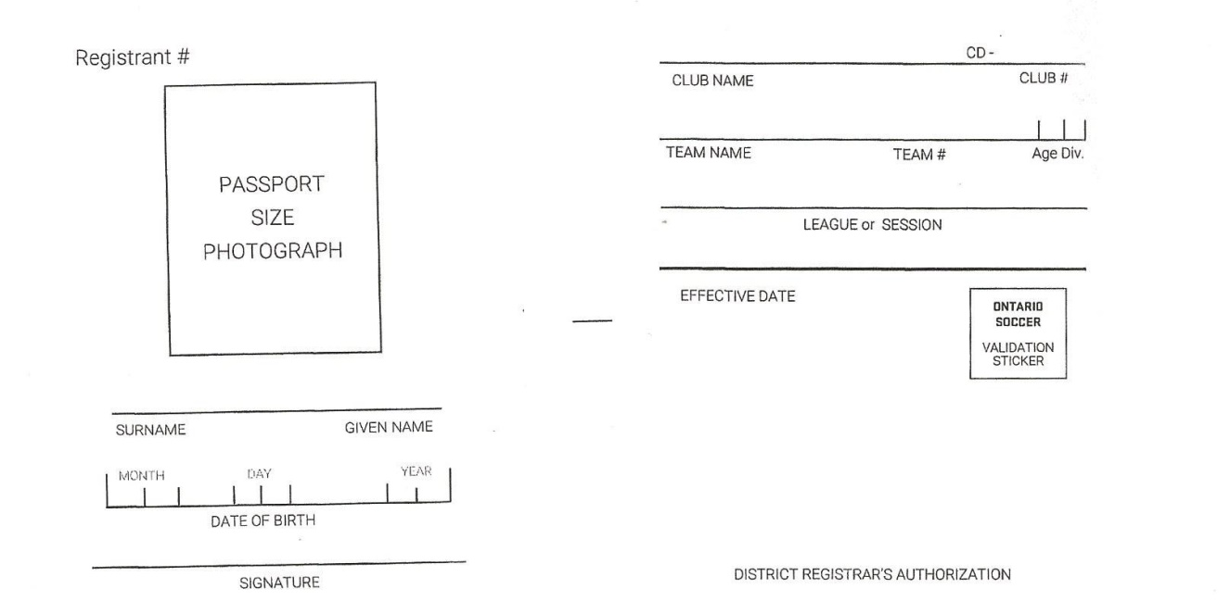

* Registration number – SESO number
* Replace youth photo every 3 years
* Apply stamp across corner of photo & date
* Print surname & given name
* Date of birth to be verified by club
* Player signature
* Club name and club CD number
* Team name and TD number plus age division of registered team
* League name, season and year
* Apply district stamp, date, and registrars name
* Confirm player ID against team rooster

**1.19** **Classification by League & Youth Levels**

**OUTDOOR**

WESTERN ONTARIO SOCCER LEAGUE [WOSL] Senior Competitive Travel (SC)

LONDON AREA WOMEN’S SOCCER LEAGUE [LAWSL} Senior Competitive Travel (SC)

CLUB SOCCER LEAGUE Senior Recreational (SR)

WEST REGION SOCCER LEAGUE Youth Competitive Travel (YC)

ELGIN MIDDLESEX DISTRICT SOCCER LEAGUE [U13-U18] Youth Competitive Travel (YC)

DISTRICT DEVELOPMENT PROGRAM (U8 – U12) Mini Outdoor Development (MO)

CLUB HOUSE LEAGUES (under 13-18) Youth Recreational (YR)

GRASSROOTS (4 – 12) Mini Outdoor (MO)

**INDOOR**

SENIOR SI (Senior Indoor Travel) SF (Senior Futsal Travel)

SENIOR SI (Senior Indoor) SF (Senior Futsal)

YOUTH YI (Youth Indoor Travel) YF (Youth Futsal Travel)

YOUTH YI (Youth Indoor) YF (Youth Futsal)

MINI MI (Mini Indoor Development) MI (Mini Futsal Development)

MINI MI (Mini Indoor) MF (Mini Futsal)

**Form A – Volunteer Screening Form**



2.0 **TEAM REGISTRATION PROCEDURES**

**2.1** **District Requirements For Validation of U13 and Older roster and books**

a) Clubs/Academies registering Teams, Team Officials, Administrators and Players

into OSCAR must submit the following for validation by the LKSA:

* Player Registration Books, Team Officials Books
* Volunteer Screening Record of all Team Officials, submitted to the District

fully completed (see Form A)

* Appropriate Certification for all Coaching Staff (as set out by the Ontario

Soccer) listed on the inside page of the Team Officials book

* Respect In Sport for Activity Leaders Certificate Number must be written in

all Team Officials Books

* Respect In Sport for Parents Certificate Number must be written below the

signature line in all Player Books

b) Absence of any of the above will delay registration.

**2.2 Team Applications to Leagues**

These are to be submitted to the League(s) directly from your Club. Please follow your

League’s Policies. A Playing Out Application may be required.

**2.3** **Team Playing Out Application Approval Process**

For teams who wish to play in leagues outside of the Lambton Kent District, when an

appropriate league does not already exist in the District.

(a) Playing Out application is submitted by the Club to the LKSA (as found on LKSA

website).

(b) Application is reviewed for the following:

(i) Coaches’ Screening

(ii) League Sanctioning

3.0 **Registration and District validation of players pools**

**3.1** **Registration using the Ontario Soccer registration System:**

Squads as per Ontario Soccer Policies and Procedures are set up on game day and not fixed for the

entire season.

**3.2** **Validation of Player Pools (U8 – U12)**

The Club/Academy will submit Players and Team Officials Books for all in the Player Pool approved by

the Club/Academy.

Please allow enough time for processing. For more information regarding processing, please see 1.17

**4.0 OTHER REGISTRATION RELATED PROCEDURES**

4.1 **Team Official Registration**

a) Volunteer Screening is required for all Team Officials (Please refer to 1.17 for

further information). This procedure is completed by the Club or LKSA and its

screening officers.

b) Specific coaching certification is mandatory, and is determined by the age of the

squad the Coach is coaching. This information is to be recorded in their Team

Official Book for tracking purposes. Respect in Sport for Activity Leaders, MED

and Making Headway must also be listed.

c) Coaches must have their Respect in Sport for Activity Leaders Certificate number

written in their Team Official Book in order to have it validated. Please note that

the Respect in Sport for Activity Leaders Certification is valid for 5 years and

therefore, must be renewed every 5 years.

d) Clubs/Academies should have records of: Coaches Registration Form

(completed and signed), and Manager’s Registration Form (completed and

signed)

e) A person can only be designated as the Team Head Coach for a maximum of two

teams per season at any one time.

Coaches can track their own records (found in their personal “Locker”) with NCCP by

keying in their NCCP number and last name in their data retrieval website –

www.coach.ca.

4.2 **Administrator/Director Registration**

a) Volunteer Screening is required, for all administrators and directors, where

applicable. This procedure is completed by the Club and its screening officers.

b) The Administrator Registration form must be completed and signed, and kept by

the Club Registrar for their records.

**4.3 Club Head Coach and Technical Staff**

a) Volunteer Screening is required for all Team Officials, where applicable. This

procedure is completed by the Club/Academy and its screening officers.

b) Team Official Registration Form must be completed and signed by all Team

Officials, and kept by the Club/Academy Registrar for their records.

c) Team Officials books are required for all Club/Academy Head Coaches and

Technical Staff that will be required to sit on the bench for any team within their

Club/Academy. Information must also be input into the Ontario Soccer

Registration System.

d) Respect In Sport for Activity Leaders is also required for all Team Officials.

**Changes in Player Registration**

**4.4 De-Registration of a Player**

a) Players that are registered can be de-registered at any time during the season

using the “Player De-Registration form” and changing the Player’s Registration

Status in the Ontario Soccer Registration System from “Active” to “Inactive”.

Please note, the player’s registration fee is not transferable to another player

registering in his/her place. The Player (or Parent, if Player is under age 18)

must sign the Player De-registration Form. Once the form has been completed,

it must be brought to the LKSA, along with the Player Book for processing.

b) A Player De-Registration form is mandatory for anyone de-registering, especially

competitive players.

**4.5 Player Transfers Between Clubs/Academies**

a) A Player that is registered to Club/Academy A can be transferred to

Club/Academy B, during the season using the “Player Transfer” form. There is a

fee for this service. Players can transfer from one Club/Academy to another

within their District, or outside their District.

b) The Player Transfer Form must be filled in by both the releasing Club/Academy

and receiving Club/A, as well as the Player. Please note that the Player (or

Parent, if Player is under age 18) must sign the Player Transfer Form.

**See Form C – Player Transfer/De-Registration Form**

Please note Transfer Rules and dates exist within Leagues and Clubs. Know the rules

before proceeding

**Form C – Player Transfer/De-Registration Form**

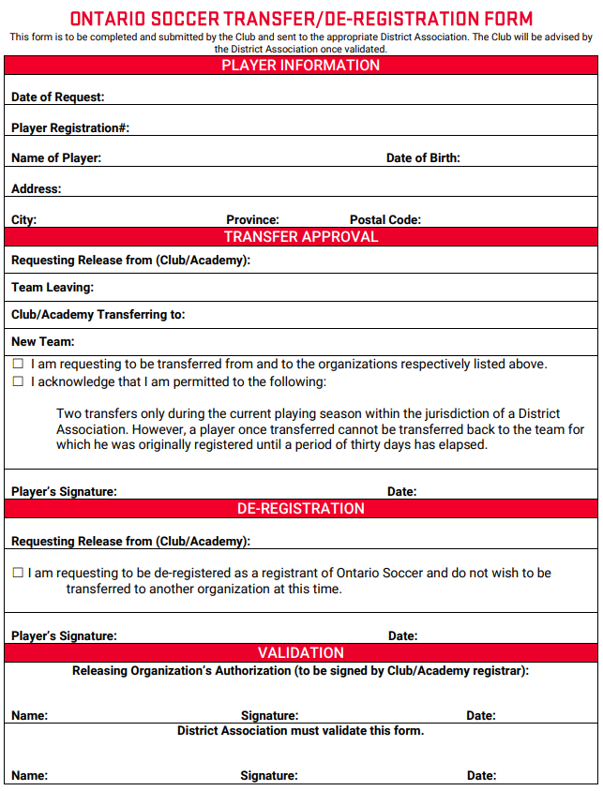

Forms are electronic and can be found on the Ontario Soccer website. Forms must be submitted

in hardcopy for approval purposes.

Fees for permits are listed on LKSA Schedule of Fees.

**4.6 Registered to Play Up Within the Same Club**

For U13 – U18 no Forms are required.

For U8 – U12 the Ontario Soccer Playing Up Form for the appropriate age group must

be completed submitted by the Club Head Coach submitted to the LKSA Technical

Director a minimum of 48 hours in advance of the game.

**See Form D – Example of Ontario Soccer Playing Up Form (**Forms for Other Age

Groups can be found on the LKSA website)

**4.7 Player Being Used as Guest Player within Same Club**

For U13 – U18 no Forms are required.

For U8 – U12 Recreational Players registered to the appropriate age group may play in a

Development League games provided the that they have been listed on LKSA

Grassroots Emergency Play Up Form that has been signed off by their Club Head

Coach. Each Guest Player may only be used a maximum of 5 games per season.

Please note that the LKSA must receive notified a minimum of 48 hours in advance

of the game to ensure that the player is available to be added to the Game Day

Roster through E2E.

**4.8 Playing from Club to Club – Temporary Eligibility Permit (U13 – U18**

**only)**

a) Any Player registered with Ontario Soccer or another Provincial Association

affiliated with Canada Soccer is eligible to obtain a Temporary Eligibility

Permit, (T.E.P.), which entitles the Player to play for a Club/Academy Team

other than the one with which he/she is currently registered.

b) This is authorized by a Club representative and LKSA.

c) The appropriate fee will be invoiced.

d) This enables a player to play one game or tournament (all games) per form.

e) A player may apply for three T.E.P.’s during each season.

f) The T.E.P. cannot be used for Cup Games.

g) In all cases in which a Player is playing for an outdoor competitive team or an

indoor team the Player must possess an Ontario Soccer Registration Book.

Failure to present the Ontario Soccer Registration Book shall render the Player

ineligible to play in that game.

**See Form F – Temporary Eligibility Permit (TEP)**

**4.9 Unregistered Player Playing “Trial Games” for a Team (U13 – U18**

**only)**

a) A Short Term Registration Permit (S.T.R.P.) is a temporary registration with

Ontario Soccer and can only be used by players who are not registered with

Ontario Soccer or a Provincial Association affiliated to Canada Soccer.

b) This is authorized by LKSA and requires the Player’s signature.

c) The appropriate fee will be invoiced.

d) A S.T.R.P. enables an unregistered Player to play two (2) league games for a

Registered Team during a fifteen day period. A S.T.R.P.. may also be used for a

Player to play in a specified tournament, or Exhibition Game (as specified on the

S.T.R.P.).

e) A Player may obtain two S.T.R.P.’s during one season.

f) A Player cannot use a S.T.R.P. more than once for the same club.

g) A Player who was previously registered with a Club during the current playing

season and who was de-registered, shall not be eligible to obtain a S.T.R.P. for

that club during the current playing season.

h) A player playing in an outdoor competitive game or an indoor game while using a

S.T.R.P. must obtain an Ontario Soccer Player Registration Book.

i) Failure to present the Ontario Soccer Player Registration Book shall render the

player ineligible to play in the game(s).

**See Form G – Short Term Registration Permit (STRP)**

**4.10 Playing in a US Tournament/Exhibition Game for a Team for which a Player is NOT**

**registered to (U13 – U18 only)**

A player may play as a Guest Player in a US exhibition game or tournament with a team from

within the province provided they are age appropriate. Please use TEP process.

**4.11 Individual Players playing for a US Team in an Exhibition Game or Tournament**

**(U13 – U18 only)**

No paperwork is required from the Club/Academy or LKSA. No Ontario Soccer Insurance

coverage is in place. Players should check with the local tournament for their rules and

guidelines. This type of involvement is voluntary and is the sole responsibility of the individual

participating in the competition.

**Form D – Example of Ontario Soccer Playing Up Form**

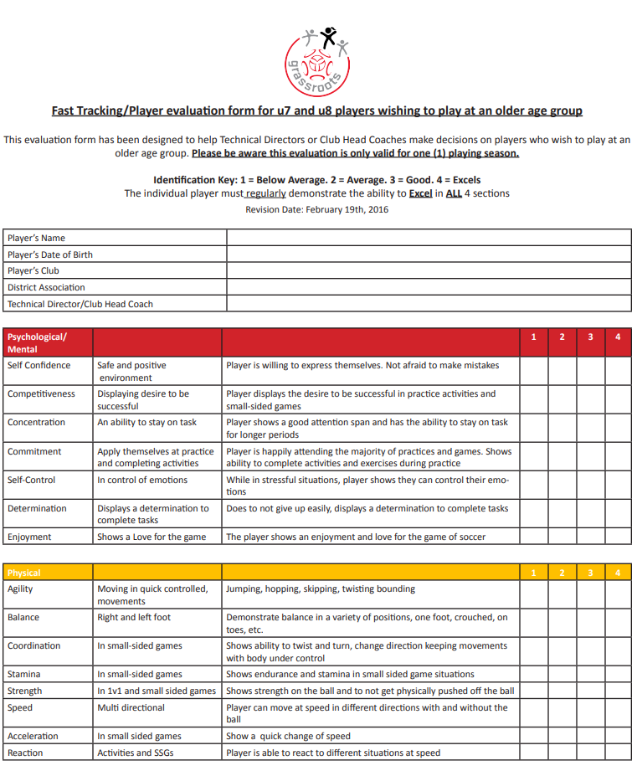

**Form F - Temporary Eligibility Permit (TEP) (U13 – U 18 only)**

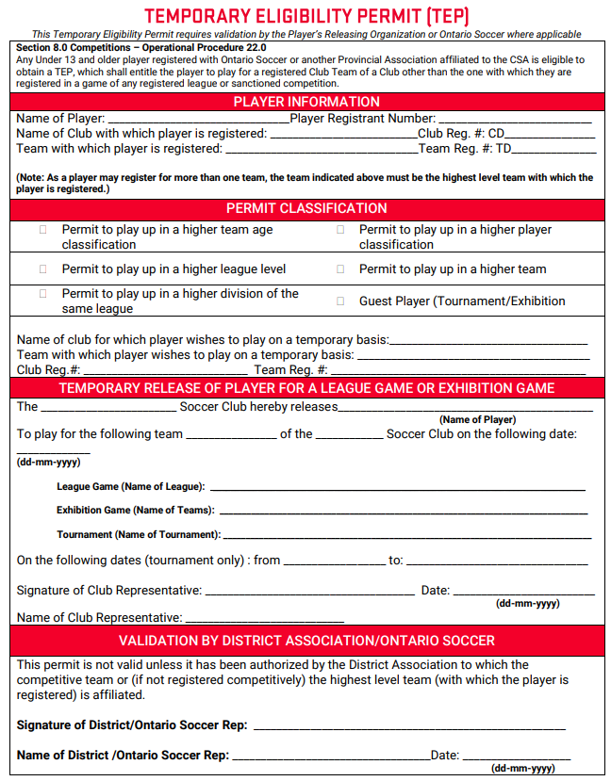

**Form G – Short Term Registration Permit (STRP) (U13 – U 18 only)**

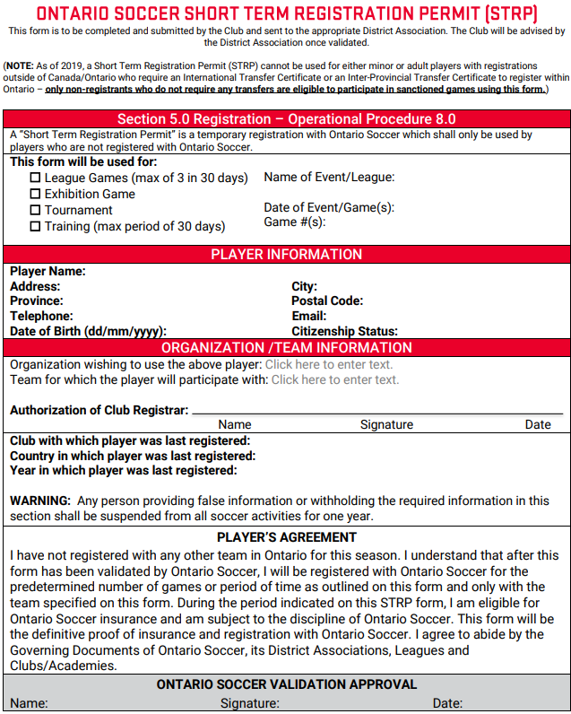

5.0 3rd PARTY INSURANCE CERTIFICATE REQUEST

Forms are electronic and can be found on the Ontario Soccer/DRSA websites.

Forms must be completed, including Club/Academy Information, and the appropriate 3rd

Party/Certificate Information. Ensure that the correct information is given – i.e. insurance for

schools should reflect the appropriate School Board and not the individual School. The School

information can be provided under the Reason for Certificate Insurance section.

Forms are sent to LKSA. When sending Forms to LKSA, ensure that they are saved as PDF

files and do not click on Send from the Forms screen. LKSA will in turn forward to HKMB.

Completed Insurance Requests will be returned within approximately 24 hours to the appropriate

Club (with a copy to the District).

**Form H – Certificate of Insurance Request Form**

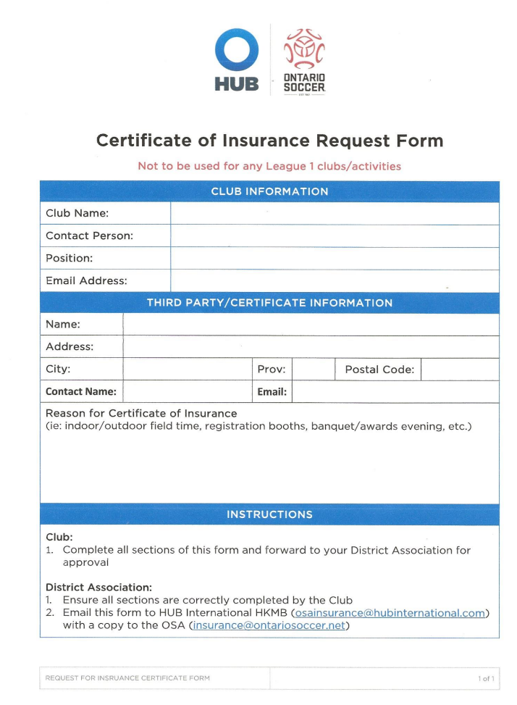

**6.0 PLAYER TRANSFERS**

**6.1 International Transfers**

For more information regarding International Transfers, please refer to the Ontario Soccer

Operational Procedures - Registration – Section 5, Procedure 12

**7.0 TRAVEL PERMITS**

**7.1 Travel Permits (ATF)**

a) The Application to Travel Form (ATF) is electronic and online (CTMS). The

application requires LKSA and sometimes Ontario Soccer and Canada Soccer

approval. Please allow the allotted amount of time for processing. These online

forms are found at: http://ctms.ontariosoccer.net/.

Please allow sufficient time for processing:

Region to Region 2 business days

North American 7 business days

Outside North America 90 days

b) For every tournament/festival that you enter outside the District you must obtain a

Travel Permit (ATF) approved by your Club/Academy and the LKSA.

c) It is mandatory for all Teams (Players and Team Officials) traveling outside of

Ontario to purchase Accident and Liability Insurance before the Travel Permit is

approved by the LKSA. Insurance can be obtained through the HKMB

Insurance Company. For more information on how to obtain team travel

insurance, please visit this website: http://www.hubinternational.com/enca/programs-associations/ontario-soccer. A copy of the travel insurance must

accompany your ATF along with verification that the tournament has been

sanctioned by the Parent organization of the Club hosting the tournament and a

copy of the tournament rules.

d) A team must be registered before an ATF will be approved.

e) Team Officials must have completed certification and screening requirements

where applicable. This is the responsibility of the Club/Academy to validate.

f) A team entering a tournament must meet the classification level of the tournament

in order to apply for permission to travel. For example: competitive teams enter

competitive tournaments.

g) An ATF is not required for travel to any games in the Ontario Cup or within the

same District the team is registered in.

**7.2 Approval and Travel to Exhibition Games (U9 and Older)**

Blanket Sanctioning can be obtained from the LKSA which allows Clubs/Academies to

host exhibition games/scrimmages between teams within their own Club/Academy. All

players must be registered to participate, no AHEG is required. Game sheets must

be retained by the Club/Academy for review by LKSA.

All Exhibition Games held between two teams from different Clubs/Academies within the

District require an Application to Host an Exhibition Game (AHEG) form found in Ontario

Soccer’s CTMS. This is an on-line form which must be approved by your Club/Academy

and then LKSA.

All exhibition games held between two teams from different districts require an AHEG,

and Travel Permit (ATF) if necessary. These forms are found in Ontario Soccer’s CTMS

and require your Club/Academy and LKSA approval.

Only one exhibition game will be approved per day, per team regardless of the

host.

Players participating in these competitions must be fully registered.

All exhibition games/scrimmages must be recorded on fully completed game

sheets for insurance purposes and discipline reporting.

Failure to complete and forward the fully completed game sheet to LKSA within 48

hours of the conclusion of the game will result in a fine and may impede approval

of future exhibition games/scrimmages